Meeting Minutes – Bentley Green Community Group (Old Rec Project)

30 March 2026 – 7.30pm – Bentley Memorial Hall

Attendees
Jade, Jane, Mottie, Charmaine, Dick, Duncan, Liz, Sue, Sarah. Chris, Lucy, Brigid, Rob, Robin, Catherine

Welcome & Introductions
Jade opened the meeting, welcomed attendees, and set an informal, collaborative tone. She emphasised that:
- No one is “the expert”; everyone brings useful skills and experience.
- The group now has parish council permission to proceed with early planning.
- The aim is to shape the future of the Old Rec together.

Attendees introduced themselves, sharing how long they’ve lived in the village, their interests, and their motivations for joining the project. Examples include:
- Long-term residents with memories of the Old Rec as a cricket field and village fête site.
- Newer residents wanting to get involved in community life.
- People with backgrounds in wildlife, conservation, local history, and community events.
- Several individuals already involved in village groups (wildlife, fête committee, conservation, etc.).

Naming the Site
A community vote was held via the mailing list.
- 87.5% of respondents voted.
- The chosen name: Bentley Green.
- Brigid confirmed the name is historically accurate, appearing on maps as far back as the medieval period.

A possible strapline was discussed, e.g. “Bentley Green – Community Orchard & Wildlife Meadow”.

Next steps:
- Announce the name publicly (pending parish council confirmation).
- Include the announcement in the Parish Magazine.

Parish Council Liaison
Key points raised:
- The parish council is supportive but meeting dates have been secured.
- The land is currently leased for horse grazing; clarity is needed on when that ends.
- There are covenants on the land:
  - No structures, even temporary ones.
  - Current permitted use is amenity/agricultural, not recreation.
- Public liability insurance needs confirming.
- A constitution is required to formalise the group as a community organisation (not a charity yet).
- Parish council may act as the banking body for funds and VAT reclaim.

Finance & Fundraising
Discussion included:
- Need for a treasurer to manage accounts and reporting.
- Parish council may contribute financially once a plan is agreed.
- Fundraising ideas already underway:
  - History walks led by Brigid and Jade.
  - Future events and community activities.
- Potential for villagers to sponsor or plant trees in the orchard or copse.

Roles Needed in the Group
The group reviewed a proposed structure. Roles include:
Essential roles
- Chair – Jade (agreed for the first year)
- Secretary – Charmaine
- Treasurer – vacant

Project-specific roles
- Orchard Lead – to guide design, planting, varieties, and management. Suggestion of Simon Slater – Sue to contact.
- Ecology & Conservation Lead – to oversee biodiversity planning – vacant. Suggestion of Hugh Pike for Tree Warden – Lucy to contact.
- Education Lead – Suggestion of Jo (school, nursery, Scouts, etc.).
- Grant Application Lead – Jane + vacant.
- Comms Lead & DPO – Jane.
- Fundraising Lead – Mottie + vacant. Suggestion of Antonia/Julia - Mottie to contact.
- Volunteer Lead – to organise working parties. Jade + Lucy.
- Events Lead – to activate the space early (e.g., birdwatching, stargazing, story time) - vacant
- Parish Council Representative – John Fuller.

Early Site Vision
A draft concept plan was shared (not final). Ideas included:
- Community orchard
- Wildflower meadow
- Butterfly meadow
- Mini-forest / copse
- Natural play features
- Pond restoration (two historic ponds identified)
- Signage and information boards
- Dog-on-lead zones to protect wildlife areas

The group emphasised that this is not a final design, just a starting point for discussion.

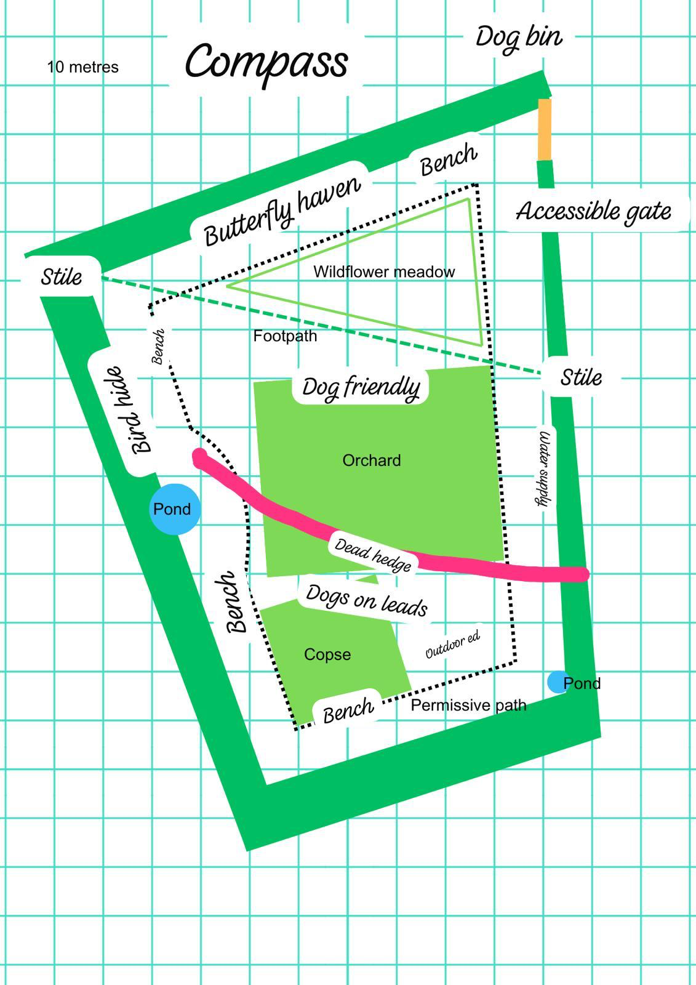

Dogs on Site
Key considerations:
- Wildlife areas may require no dogs or dogs on leads.
- A dog bin may need relocating rather than adding a new one (due to council limits).
- Clear signage will be essential.

Communications
Channels to be used:
- Parish Magazine
- Parish Council website (via Bentley Wildlife link)
- Social media groups
- Noticeboards
- Posters at the field gate
- QR codes linking to mailing list and project updates

Grants Update
- East Hants grant: unsuccessful (funds already allocated).
- Woodland Trust grant: successful – 30 native trees arriving in November for the copse.
- More grants will be pursued.

Other Ideas & Suggestions
- Stand at the village fête to raise awareness and funds.
- Engage Forestry Commission or Environment Agency for advice.
- Use local craftspeople for signage.
- Capture oral histories and old photos of the Old Rec.

Closing
The group thanked Jane and Jade for their leadership and energy.

Action Items
Action | Owner | Status
Email Parish Council to confirm new name | Jade | In progress
Approach Simon Slater re Orchard Lead role | Sue | In progress
Approach Hugh Pike re Tree Warden role | Lucy | In progress
Approach Antonia/Julia re Fundraising Lead role to support Mottie | Mottie | In progress
Email list of roles needed to everyone who attended meeting | Jane | In progress
Arrange noticeboard and 30x tree guards for the copse | Chris | In progress

Next Meeting
Monday 27 April – 7.30pm – Bentley Memorial Hall (upstairs room)

